**Building a Smarter AI-Powered Spam Classifier**

Building a smarter AI-powered spam classifier involves using advanced machine learning techniques, such as natural language processing (NLP) and deep learning, to enhance its accuracy. You can consider the following steps:

**Data Collection:**

Gather a large and diverse dataset of emails, labeled as spam or non-spam (ham), to train your classifier. The quality and quantity of your data greatly influence the model’s performance.

**Data Preprocessing:**

Clean and preprocess the text data by removing special characters, stop words, and performing stemming or lemmatization. This step prepares the data for the machine learning algorithms.

**Feature Extraction:**

Use techniques like TF-IDF (Term Frequency-Inverse Document Frequency) or word embeddings (like Word2Vec or GloVe) to convert text data into numerical vectors. These vectors serve as input features for your machine learning model.

**Choosing a Model:**

Experiment with various machine learning algorithms such as Naïve Bayes, Support Vector Machines, or more advanced models like Recurrent Neural Networks (RNNs) or Transformers. Deep learning models, especially those based on attention mechanisms, have shown great promise in NLP tasks.

**Training the Model:**

Train your selected model on the preprocessed and feature-extracted data. Use techniques like cross-validation to fine-tune hyperparameters and avoid overfitting.

**Evaluation:**

Evaluate the model’s performance using metrics like accuracy, precision, recall, and F1-score. Additionally, consider using techniques like ROC curves and AUC (Area Under the Curve) to assess the model’s performance comprehensively.

**Iterative Improvement:**

Analyze the misclassified samples and continuously refine your model. You can consider using techniques like ensemble learning, where multiple models are combined to improve accuracy.

**Regular Updates:**

Keep your spam classifier up-to-date by continuously feeding it new data. Spam patterns change, so the model needs to adapt to these changes.

**User Feedback:**

If possible, incorporate user feedback to improve the classifier. Users can mark false positives or false negatives, which can be used to retrain the model.

**Scalability and Efficiency:**

Ensure your classifier is scalable and efficient, especially if it’s deployed in a real-time system. Optimize the model and inference process for speed and resource usage.

Remember that the key to a smarter spam classifier lies in the quality of data, choice of algorithms, and continuous refinement based on feedback and evolving spam patterns.

**Feature engineering**

**N-grams**:

Instead of just considering single words (unigrams), you can use n-grams, which are contiguous sequences of n items (characters or words). N-grams capture local patterns and can provide better context for spam detection.

**Text Length:**

Spam emails and messages often have different lengths compared to legitimate ones. Create features based on the length of the text, such as the number of words, characters, or sentences. Unusually short or long texts might indicate spam.

Special Characters and Symbols: Spam messages often contain excessive use of special characters, symbols, or numbers. Count the occurrences of these characters and use them as features.

**HTML Tags:**

If your dataset includes email content, consider features related to HTML tags. Spam emails might use specific HTML elements more frequently than legitimate emails.

**Word Embeddings:**

Utilize pre-trained word embeddings like Word2Vec, GloVe, or FastText to represent words as dense vectors. These embeddings capture semantic relationships between words and can enhance the model’s understanding of textual data.

**Part-of-Speech Tags:**

Extracting part-of-speech tags (like nouns, verbs, adjectives, etc.) using NLP tools can provide additional linguistic information. Certain POS patterns might be indicative of spammy content.

**Sentiment Analysis:**

the sentiment of the text (positive, negative, or neutral). Spam messages might exhibit different emotional tones compared to legitimate messages.

**Domain Information:**

Extract features from email addresses and URLs, such as the domain name, top-level domain (TLD), and the presence of subdomains. Unusual or suspicious domains can be indicative of spam.

**Frequency Features:**

Calculate the frequency of words, characters, or phrases in the text. Certain words or phrases might be prevalent in spam messages.

**Contextual Features:**

Consider contextual information such as the sender’s reputation, previous interactions with the recipient, or the time of day the message was sent. Contextual features can provide valuable context for spam detection.

**Keyword Occurrence:**

Create binary features indicating the presence or absence of specific keywords or phrases associated with known spam patterns.

**Sequential Patterns:**

If dealing with sequential data (like chat conversations), extract sequential patterns or use recurrent neural networks (RNNs) to capture patterns over time.

**Different activities**

**Text Preprocessing:**

Activities such as tokenization, stemming, and removing stop words help in preparing the text data for analysis.

**Feature Extraction**

Techniques like TF-IDF (Term Frequency-Inverse Document Frequency) or word embeddings can be used to convert text data into numerical vectors, making it suitable for machine learning algorithms.

Machine Learning Algorithms: Supervised learning algorithms like Naïve Bayes, Support Vector Machines (SVM), and neural networks can be trained on labeled data to classify messages as spam or non-spam.

**Natural Language Processing (NLP):**

NLP techniques, including part-of-speech tagging and named entity recognition, can be used to understand the context of messages.

**Data Balancing:**

Techniques like oversampling the minority class (spam) or undersampling the majority class (non-spam) can help balance the dataset, improving the classifier’s performance.

**Cross-Validation:**

Activities like k-fold cross-validation ensure the model’s robustness and prevent overfitting by testing it on different subsets of the data.

**Hyperparameter Tuning:**

Optimizing hyperparameters, such as learning rates and regularization strengths, through activities like grid search or random search, enhances the classifier’s accuracy.

**Ensemble Methods:**

Combining predictions from multiple classifiers (e.g., Random Forests, Gradient Boosting) can lead to a more accurate and robust spam classifier.

**Feedback Loop:**

BCmplementing a feedback mechanism where users mark false positives and negatives can continuously improve the classifier’s accuracy over time.

**Deep Learning:**

Utilizing deep learning architectures like Recurrent Neural Networks (RNNs) or Long Short-Term Memory (LSTM) networks can capture intricate patterns in text data, improving the classifier’s performance.

**Regular Updates:**

Keeping the spam classifier up-to-date with the latest spam patterns and trends ensures its effectiveness in identifying new types of spam messages.

**Code**

# split data into train and test

X = np.array(df.embedding)

Y = np.array(df.class_embeddings)

X_train, X_test, y_train, y_test = train_test_split(X, y, test_size=0.2, random_state=42)

# train random forest classifier

Clf = RandomForestClassifier(n_estimators=100)

Clf.fit(X_train.tolist(), y_train)

Preds = clf.predict(X_test.tolist())

# generate a classification report involving f1-score, recall, precision and accuracy

Report = classification_report(y_test, preds)

Print(report)

Output

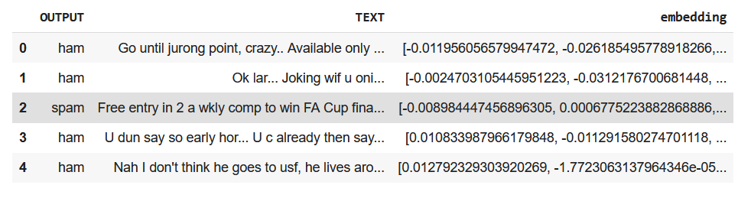

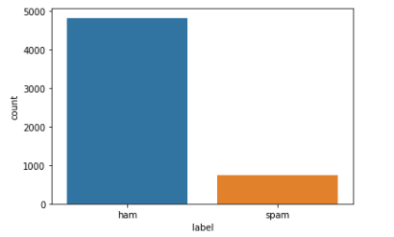modal

**Real time**

Edge detection is one of the fundamental image-processing tasks used in various Computer Vision tasks to identify the boundary or sharp changes in the pixel intensity. It plays a crucial role in object detection, image segmentation and feature extraction from the image. In Real-time edge detection, the image frame coming from a live webcam or video is continuously captured and each frame is processed by edge detection algorithms which identify and highlight these edges continuously.

In this article, we will use the Canny edge detection algorithms of OpenCV to detect the edges in real-time. It is one of the most widely used edge detection algorithms. Let’s understand the Canny edge detection in depth.

